IAM USER

1. Create a policy to access all objects in a specific bucket.

Ans.

Step 1: create the user >>>

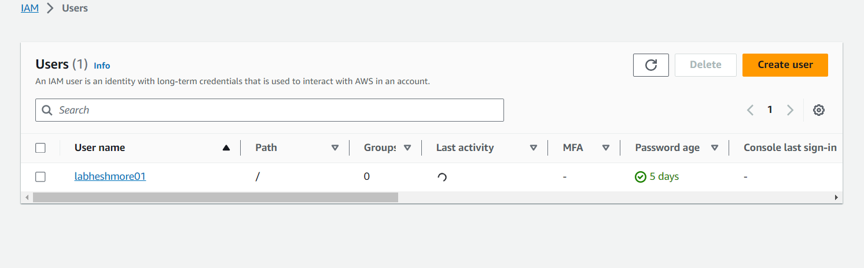

Step 2 : Set permissions >>>

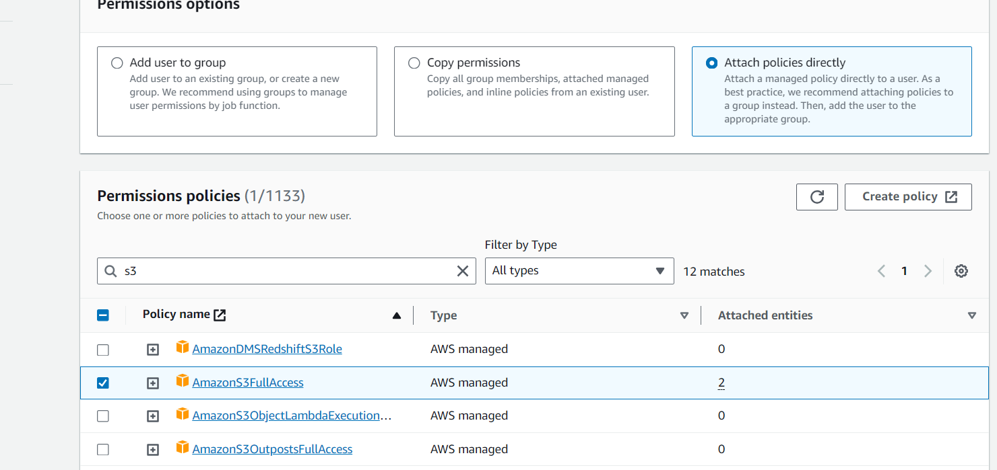

Step 3: AmazonS3FullAccess

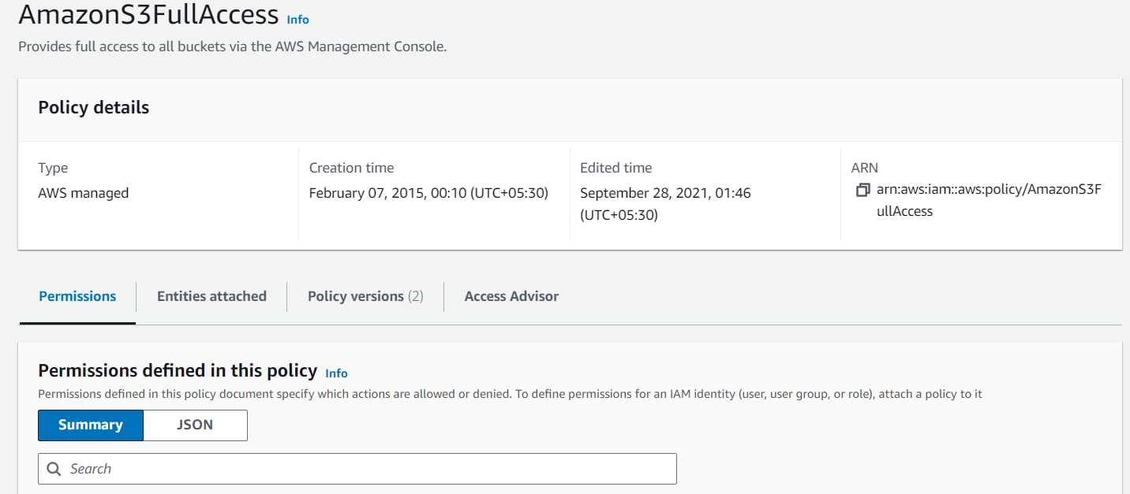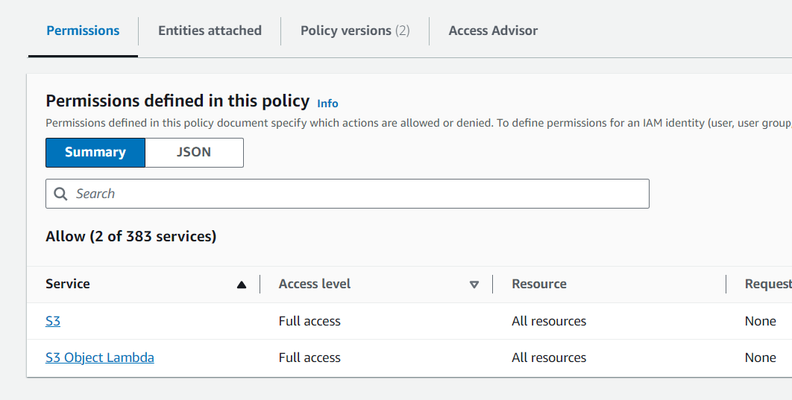

Step 4 :

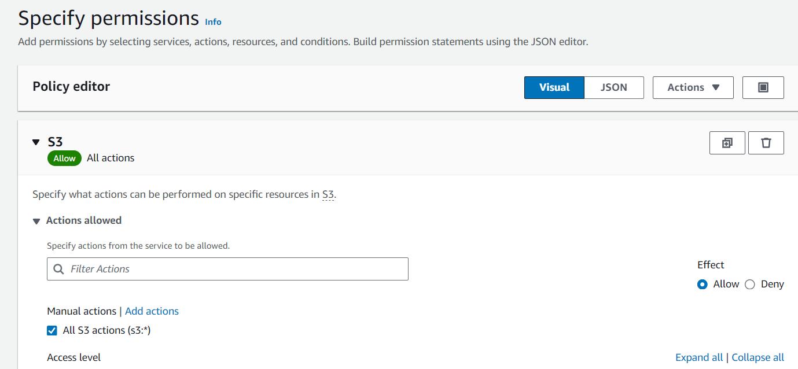

Step 5 :

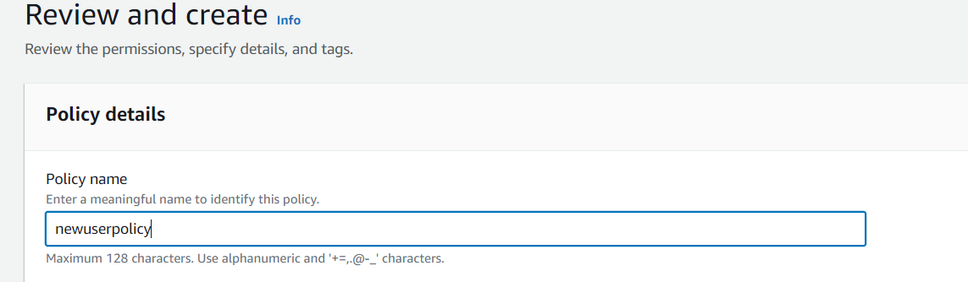

Step 6:

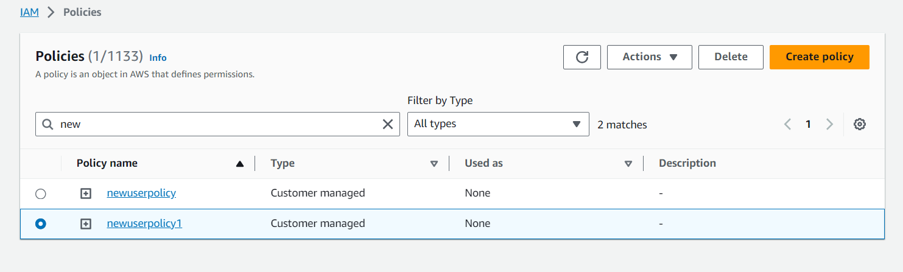

Step 7: 